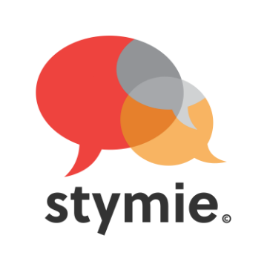

Proserpine State High School believes that students and teachers must have a safe and supportive environment to perform to the best of their ability. To achieve this, it is our aim to make the school a bully-free environment.

Rachel Downie the founder of STYMIE recently visited our junior school and spoke about several factors that negatively affect young people in our schools, home and community. It is a hard hitting half hour presentation that delivers not only the problem but also possible solutions.

Rachel spoke to the students about bullying, cyberbullying, verbal harassment and choice of words, sexploitation (sending nudes/being held to ransom) and their harmful effects on young people.

Proserpine State High School has implemented the STYMIE Program across all year levels in 2017 with the focus on enabling students who witness bullying to send anonymous electronic notifications to the school. The STYMIE resource is now promoted as a system to report any behaviour or incident that could cause harm to another person in our school.

Parents can also complete notifications through STYMIE by simply accessing the STYMIE site.

**How does STYMIE work?**

1. Stymie allows bystanders to send anonymous notifications to your school, about someone who they believe is being bullied or potential risk to someone.
2. The notification interface allows bystanders to upload evidence like screen shots of FB discussions, Snapchats, text messages or instant message conversations and an outline of the incident(s). Click here to view the notification page <https://www.stymie.com.au/>.
3. The school receives the STYMIE notifications in the form of an email alert. You may choose which members of staff receive these emails.
4. The notifications are encrypted, anonymous and confidential. STYMIE does not store any information; they are merely the road upon which it travels.

Proserpine State High School is committed to harnessing the power of bystanders to change the “culture of acceptance” of bullying in our community.

More information can be found via the links below:

<http://www.stymie.com.au/>

<http://www.facebook.com/stymie.au>

