1 x HERCUS 260 METALWORK LATHES WITH STAND.
1 x WOODFAST BANDSAW
OFFERED FOR SALE BY INVITING OFFERS

Process:
The listed items are being made available for sale by Proserpine State High School via inviting offers. Offers must be submitted in writing using the attached document [page 2].

Timeline:

Offers will be accepted from 12 May 2026 to 22 May 2026 at 5pm
No offer will be accepted after this time.
Persons submitting the successful offer will be notified and are asked to finalise payment, no later than
29 May 2026.
Payment by credit card please is preferred.
A collection time must be arranged with Mike Edmonds from Bus Shed by calling the school on 4945 0111.
All removal charges are the responsibility of the successful tenderer with all items required to be removed by no later than 29 May 2026 as negotiated with Mike Edmonds.

“CONFIDENTIAL – OFFER FOR ITEMS” “CONFIDENTIAL – OFFER FOR ITEMS”

Business Manager
Proserpine State High School
4 Ruge Street or PO Box 220
Proserpine Qld 4800

Condition and Inspection of Goods:
1 x Hercus 260 Metalwork Lathe with stand. Equipment was operational when removed from the workshop. Lathe has been removed from stand and will need to be reinstalled.
- Model ATM- Serial -18928
1 x Woodfast Bandsaw. 3 Phase. Equipment was operational when removed from the workshop.
- Model 400

Note: Items available for sale by inviting offers may not be fit for use. It is the buyers/owners responsibility to ensure that a suitable inspection is undertaken, prior to use, and the items be brought to a condition which complies with relevant State Legislation, Regulations and applicable Codes of Practice.

After the Sale:
No warranty or backup service is available, either implied or stated. After an item has been removed from the school.

Conditions:
The Department of Education reserves the right not to accept an offer, and may set a reserve price. Whilst all care has been taken, the Department of Education disclaims all liability for loss or damage to person or property arising from the removal and subsequent use of any item on offer. Any and all utility services, above and underground, are clearly marked and all care should be taken by the remover to avoid these.
Persons submitting offers must disclose any interest or links with departmental employees.

1 x HERCUS 260 METALWORK LATHES WITH STAND.
1 x WOODFAST BANDSAW
OFFERED FOR SALE BY INVITING OFFERS

This document should be enclosed in an envelope marked “CONFIDENTIAL – OFFER FOR ITEMS” and submitted in person OR by email to njoll4@eq.edu.au

Business Manager
Proserpine State High School
4 Ruge Street or PO Box 220
Proserpine Qld 4800

Please ensure the offer arrives at the school no later than 22 May 2026.
All items are required to be removed by no later than 29 May 2026.

OFFERER’S DETAILS NAME:
ADDRESS:
PHONE NUMBER(H): | Tick preferred method of notification
PHONE NUMBER (W/MOB):
EMAIL:

PLEASE CIRCLE BELOW:
I do / do not have any interest or links with departmental employees.

If answered, “I do” please provide further details:

ITEM Lot # | Item Description | Bid on this Item ($)
Lathe 1 | Herco 260 Metalwork Lathes
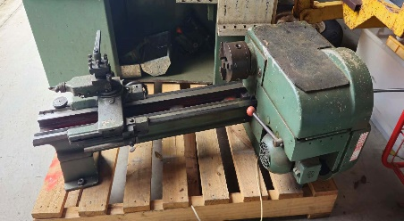 | 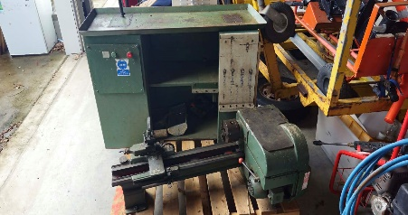
Bandsaw
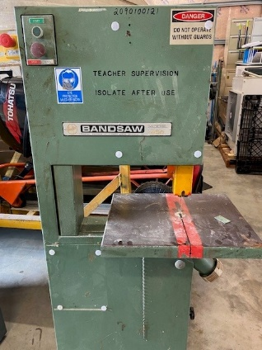

Offeror Name: ______________________________ (SIGNED) Date: ______ / ______ / 2026

